CAPSTONE PROJECT – SAKILA DVD

RENTAL STORE ANALYSIS

By BISWARUP DEY (Data Analyst, AccioJob)

PROJECT OVERVIEW

Welcome to the Sakila DVD Rental Analysis Documentation. In this document, I will outline the key components of my analysis, which include Sales Revenue Analysis, Store and Inventory Analysis, Customer Demographic Analysis, and Film Rental Analysis using Excel, SQL & Power BI. This comprehensive examination of DVD rental business aims to provide valuable insights, inform decision-making, and enhance our overall performance.

OBJECTIVE

The principal aim of this project is to conduct an extensive Exploratory Data Analysis (EDA) utilizing the Sakila DVD Rental Store Database. The objective is to extract valuable insights pertaining to the rental store's operations, with a specific focus on customer behavior, film rental patterns, store and inventory management, and sales growth.

This analytical endeavor is intended to provide the foundation for the development of a comprehensive Power BI dashboard, which will empower stakeholders with data-driven decision-making capabilities. The ultimate goal is to enhance the overall business performance through informed strategic actions.

**Sales Revenue Analysis**

Objective: To understand the performance of our sales activities.

In Sales Analysis, we will:

* Examine sales trends and patterns for DVD rentals.
* Analyze sales by time periods, such as monthly, and annually.
* Identify top-rented movies and their impact on revenue.
* Assess the effectiveness of sales channels and store locations.

**Store & Inventory** **Analysis**

Objective: To gain insights into our stores and inventory.

In Store and Inventory Analysis, we will:

* Evaluate the performance of our different rental store locations.
* Analyze inventory turnover and the availability of popular movie titles.
* Examine rental trends, including peak rental times and popular movie genres.
* Identify opportunities to optimize inventory management and store operations.

**Customer Demographic Analysis**

Objective: To understand our customer base and their preferences.

In Customer Demographic Analysis, we will:

* Segment customers based on demographic factors such as age, spendings, and location.
* Analyze customer movie preferences and rental behavior.
* Assess customer loyalty and lifetime value.
* Tailor marketing and movie offerings to specific customer segments.

**Film Rental Analysis**

Objective: To evaluate the performance of our movie rentals.

In Film Rental Analysis, we will:

* Examine movie rental trends, including the popularity of specific genres.
* Analyze the performance of movie titles in terms of rentals and revenue.
* Assess the impact of movie availability and customer demand.
* Identify opportunities to enhance our movie rental offerings and promotions.

SIGNIFICANCE

The Sakila DVD rental analysis, based on the provided tables, holds significant value for a DVD rental business. Here are a few key points regarding the significance of this database:

1. Inventory Management: It allows for effective management of the DVD inventory by providing information about films, their rental rates, durations, and categories. This data is crucial for optimizing stock levels and pricing strategies.

2. Customer Insights: The customer-related tables (customer, payment, rental) provide insights into customer behavior, rental patterns, and payment history. This information helps in understanding customer preferences and tailoring services to their needs.

3. Staff and Store Management: The staff and store tables enable tracking of staff assignments, store locations, and manager-staff relationships. This is essential for efficient store operations and staffing.

4. Language and Cultural Diversity: The language and country tables are valuable for businesses serving diverse communities. They help in offering films in various languages and tailoring services to different cultural backgrounds.

5. Film and Actor Information: The film and actor tables provide details about films and actors, allowing for effective categorization, recommendation systems, and insights into popular actors or genres.

6. Rental Data: The rental and inventory tables offer data about when films are rented and returned, which is vital for tracking rental duration and late returns. It aids in billing and customer service.

7. Payment Records: The payment table helps track revenue and customer payment history. It is essential for financial reporting and identifying payment trends.

8. Geographical Insights: The city and country tables provide geographical information that can be useful for analyzing business performance across different regions.

9.Data Visualization Skills: Working with Sakila data provides an opportunity to enhance data visualization skills. Creating meaningful charts, graphs, and reports from the data helps individuals convey their findings effectively and make data more understandable to stakeholders.

In summary, the Sakila DVD rental database serves as the backbone for managing a DVD rental business efficiently. It enables inventory optimization, customer satisfaction improvement, staff and store management, and insights into customer preferences and behaviors. It is a valuable tool for enhancing business operations and profitability.

PROCESS

1. Data Acquisition from GitHub:

Obtained the valuable dataset from designated GitHub repository provided by AccioJob. The dataset contains essential information about films, actors, rental information, customers’ information, address, city, country, staffs, stores, inventory & payment details.

1. Connecting with Tools:

Established connection between the dataset and the required tools for analytical purpose. Interface the given dataset (.csv file) with Excel & Power BI and connected the SQL files to MySQL Workbench.

1. Data Transformation & Enhancement:

Executed data transformation procedure in Power Query editor to derive some additional data required for data analysis purpose. To be specific, I used some DAX functions like Related(), Datediff() etc. to create additional columns to extract meaningful insights. Also created a new table as country_region in SQL for required analysis.

1. Exploratory Data Analysis (EDA):

Performed EDA using excel & MySQL workbench depending on the required problem statements to extract meaningful insights, patterns, relationship & trends from the dataset to enhance business decision-making.

1. Problem Statement Solution & Dashboard Development in Power BI:

Extensively used Power BI to dive into the problem statements and explored its robust features to build data visualization, derive insights & solutions.

1. Creation of Insightful PowerPoint & Detailed Documentation:

Created a detailed report to document the entire project life cycle including data collection, transformation, problem statement formulation, EDA insights, Power BI Dashboard building and PowerPoint presentation.

DATA DICTIONARY

Sakila DVD Rental Store database comprises several interconnected tables, each containing specific data related to the operation of DVD rental business. Here is the overview of the primary fields of the tables in Sakila database

**Table film _text**

* film _id: Unique identifier of each film in film_text table
* Description: Details about the film.

**Table category**

* category _id: Unique identifier for different categories of films.
* name: Name of each film

**Table film _category**

* category _id: Primary Key
* film_id: Foreign Key referencing film_id of the film table

**Table** **film**

* language _id: Primary key
* rating: Different film ratings
* rental _rate: Rate of rental of each film
* rental _duration: Renting time period.

**Table language**

* language_id: Unique identifier of language table
* name: Consists different languages

**Table inventory**

* inventory_id: Unique identifier of this table
* store_id: Foreign key referencing store_id of the store table
* film _id: Foreign key referencing film_id of the film table

**Table rental**

* rental _id: Primary key of rental table
* rental_date: Date the film rented
* return _date: Return date of the film rented
* inventory id: Foreign key referencing inventory_id of the inventory table

**Table payment**

* amount: Payment received from customer
* customer_id: Foreign key referencing the customer_id of customer table
* payment _id: Primary key
* rental _id: Foreign key referencing the rental_id of rental table
* staff_id: Foreign key referencing the staff_id of the staff table
* payment_date: Information about the payment date

**Table customer**

* active: Identifies whether the customer is active or not
* address_id: Foreign key referencing the address_id of address table
* customer ID: Primary key of customer table
* email ID: Email id of customer
* first name: First name of customer
* last name: last name of customer
* store_id: Foreign key referencing store_id of the store table.

**Table address**

* address _id: Primary key of address table
* city _id: Foreign key referencing city_id of city table

**Table city**

* city_id: Primary key of city table
* country_id: Foreign key referencing country_id of the country table
* city: name of city

**Table country**

* country_id: Primary key
* country: name of the country

**Table store**

* address_id: Foreign key referencing address_id of address table
* Store_id: Primary key of the store table
* manager_staff_id: Foreign key referencing staff_id of staff table

**Table staff**

* address_id: Foreign key referencing address_id of address table
* staff_id: Primary key of staff table
* stored_id: Foreign key referencing store_id of store table

**Table film _actor**

* actor_id: Foreign key referencing actor_id of actor table
* film_id: Foreign key referencing film_id of film table

**Table actor**

* actor_id: Primary key of actor table
* first name: First name of actor
* last name: Last name of actor

ER DIAGRAM

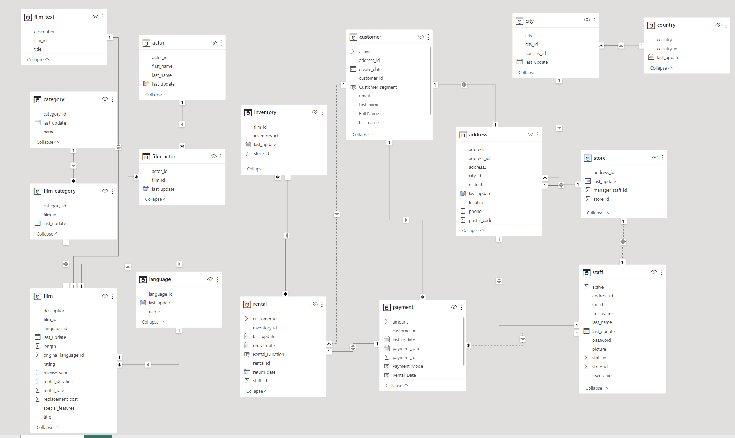

EDA

1. What are the purchasing patterns of new customers versus repeat customers?

Distinguishing between purchasing patterns, new customers tend to make infrequent, smaller orders, initially opting for popular products. In contrast, repeat customers exhibit more regular and substantial purchasing behavior, exploring a broader product range. They also engage in providing valuable feedback, contributing to a deeper customer-brand relationship. These insights inform strategic marketing and customer retention efforts.

After analyzing the dataset and running relevant SQL queries I found out that all customers are repeated customers and have rented DVDs multiple times. Hence, I can conclude that there are no new customers to analyze purchasing pattern of new customers versus repeat customers.

But I have analyzed purchasing pattern of customers based on recent and old rental orders i.e., who have ordered DVDs in last 30 days and who haven't.

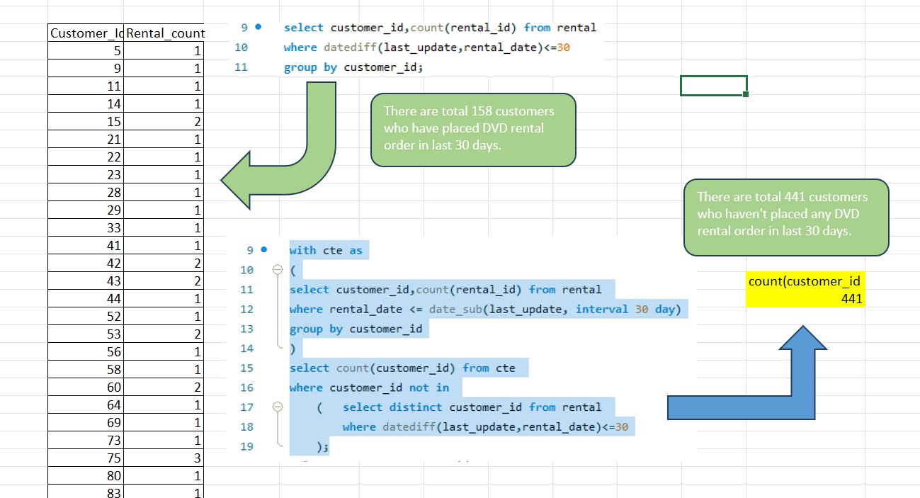

1. Which films have the highest rental rates and are most in demand?

Movies that are in high demand are often the favorites of customers, which is why they order them repeatedly. Customer preferences play a significant role in determining which films are in demand, and popular films tend to be rented more frequently. Understanding these preferences is essential for businesses to cater to customer needs and optimize their film offerings.

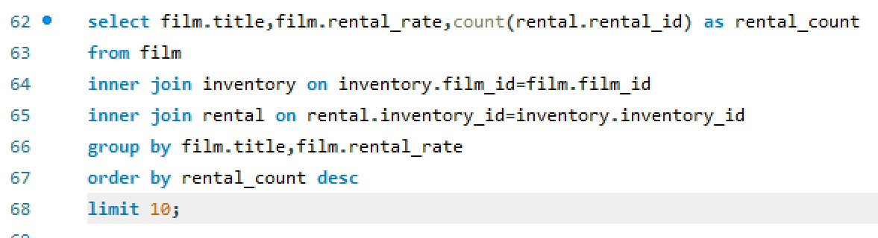



|  |  |  |
| --- | --- | --- |
| FILM TITLE | Category | Rating |
| BUCKET BROTHERHOOD | Travel | PG |
| FORWARD TEMPLE | Games | NC-17 |
| GRIT CLOCKWORK | Games | PG |
| HOBBIT ALIEN | Drama | PG-13 |
| JUGGLER HARDLY | Animation | PG-13 |
| RIDGEMONT SUBMARINE | New | PG-13 |
| ROBBERS JOON | Children | PG-13 |
| ROCKETEER MOTHER | Foreign | PG-13 |
| SCALAWAG DUCK | Music | NC-17 |
| ZORRO ARK | Comedy | NC-17 |

Analyzing the dataset, I can conclude that the films “Bucket Brotherhood” has the highest rental rate and also it is most demanded. I figured out the most demanding film by taking the number of times a film has rented. Also we can see from the table what are the rating and category of movies preferred by the consumers.

1. Are there correlations between staff performance and customer satisfaction?

Yes, there is often a correlation between staff performance and customer satisfaction. When staff members provide excellent service, are knowledgeable, and handle customer inquiries and concerns effectively, it tends to result in higher customer satisfaction. Positive interactions with well-performing staff can lead to increased customer loyalty and positive word-of-mouth recommendations, ultimately benefiting the business.

NOTE: There is no relevant data available regarding staff performance or customer satisfaction in the given dataset. To understand staff performance, we need data like customer rating or feedback for staffs, store performance. Also, to get insight about customer satisfaction we need data on customer feedback.

So, I have gained insight about pricing impact on Rental Revenue which is one of the problem statements in my MECE breakdown of the given dataset.

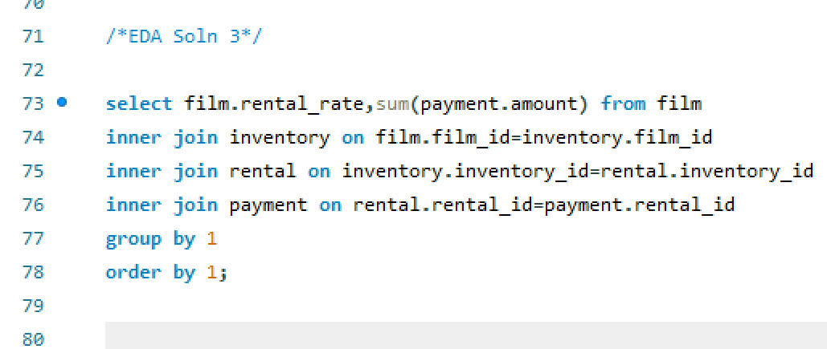

By observing the chart, we can clearly understand that as the rental rate of films increases so as revenue. The positive correlation between film rental rates and revenue suggests that businesses should focus on strategies that encourage more rentals, customer satisfaction, and effective marketing.

1. Are there seasonal trends in customer behavior across different locations?

Yes, there are often seasonal trends in customer behavior across different locations. These trends can be influenced by factors such as weather, holidays, cultural events, and local traditions. Understanding and adapting to these seasonal trends is crucial for businesses to optimize their operations and marketing strategies accordingly.

To deal with the problem statement at first, I have segregated different countries into different locations and created a new table in SQL as country_region with two fields country & regions.

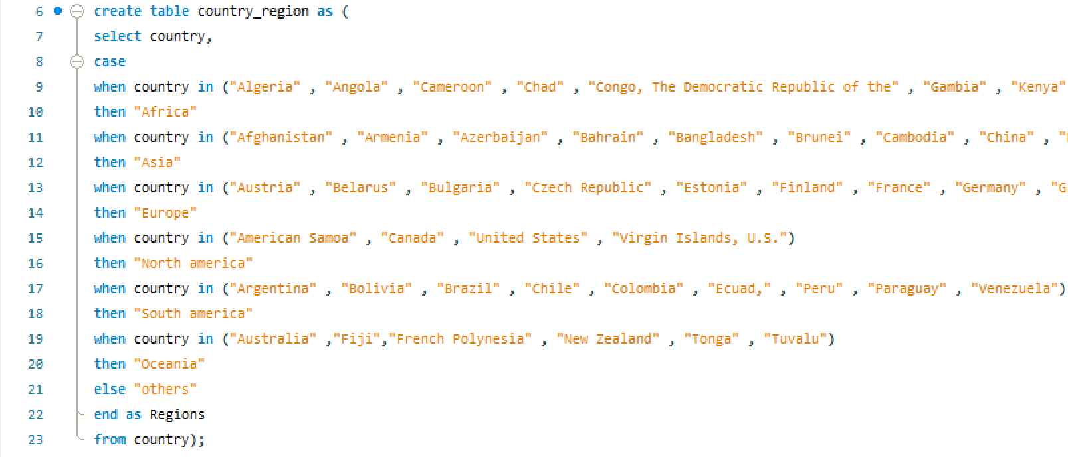

Then I derived the monthly sales over time and reached out to a conclusion that maximum revenue got generated in July & August followed by May & Jun.

To find out season I have taken July & August as Autumn/Spring (based on countries location either in northern hemisphere or southern hemisphere) and May, Jun as Summer/Winter.

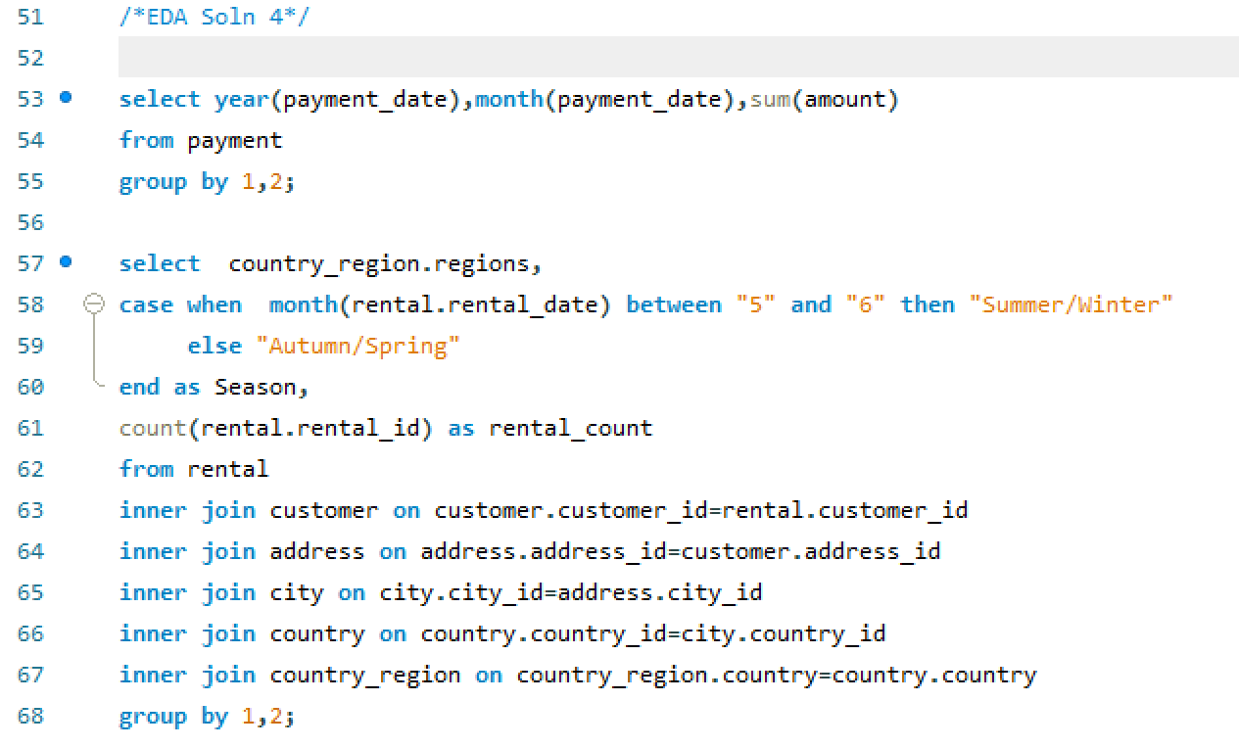

By observing the above chart, I can conclude that Asia region has the highest number of movies rented in autumn or spring followed by the others region and Oceania region has the lowest number of movies rented.

1. Are certain language films more popular among specific customer segments?

Certain language films are more popular among specific customer segments based on cultural and linguistic preferences. For example, Bollywood films for South Asian audiences or Hollywood films for a broader international audience.

NOTE: The above problem statement cannot be solved from the given dataset as all the films are in English language in the film table.

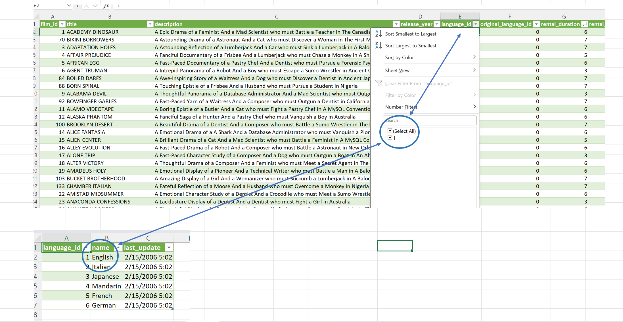

1. How does customer loyalty impact sales revenue over time?

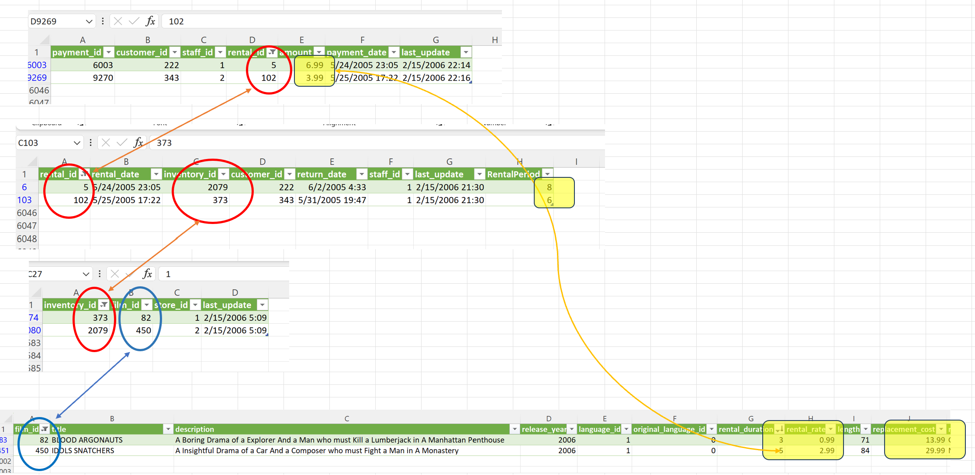

NOTE: There is no co-relation between payment amount and rental_rate. To justify my findings, I have taken 2 sample payment_id from payment table and trailed to Film table to find out the co-relation. Unfortunately, there is no relevant data to justify payment accepted and rental_rate based on rental duration.

Customer loyalty impacts sales revenue over time by increasing repeat business, average transaction value, and word-of-mouth referrals while reducing customer acquisition costs and churn, leading to stable and sustained revenue growth.

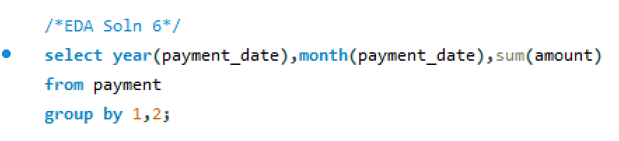

Hence, I have taken only payment received to find out revenue over time. There was no transaction and rental data available between Sept'05 to jan'06. And then a sudden drop in Feb'06.

Customer loyalty significantly impacts sales revenue over time. Loyal customers make repeat purchases, spend more per transaction, and bring in referrals through word of mouth. They require less marketing expenditure, respond well to cross-selling and upselling, and remain with the business, reducing the need for costly customer acquisition. Loyal customers provide valuable feedback for product improvement, can drive recurring revenue through subscription models, and contribute to a resilient brand. Their long-term support fosters consistent and growing revenue, making customer loyalty a vital asset for business success.

1. Are certain film categories more popular in specific locations?

Yes, certain film categories can be more popular in specific locations. Customer preferences for film genres often vary based on cultural and regional factors. For example, romantic comedies might be more popular in one location, while action films are preferred in another. Understanding these regional preferences can help businesses tailor their film offerings to match local demand.

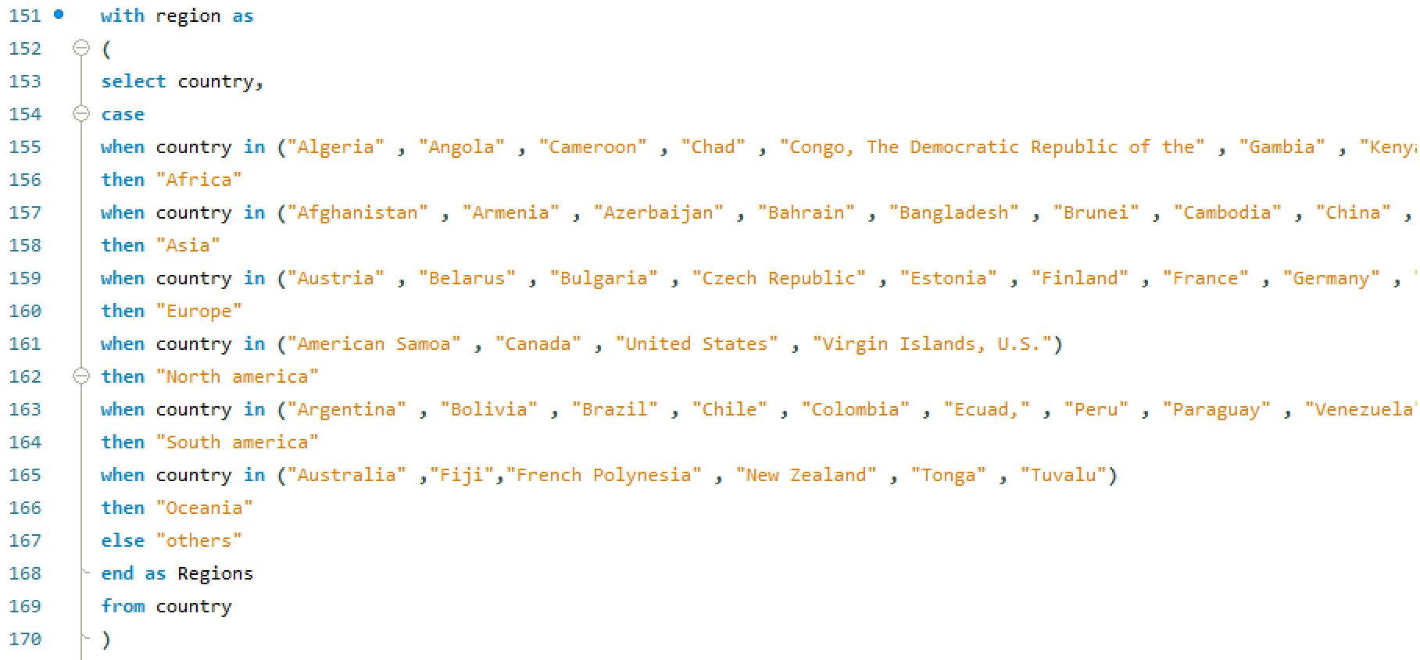

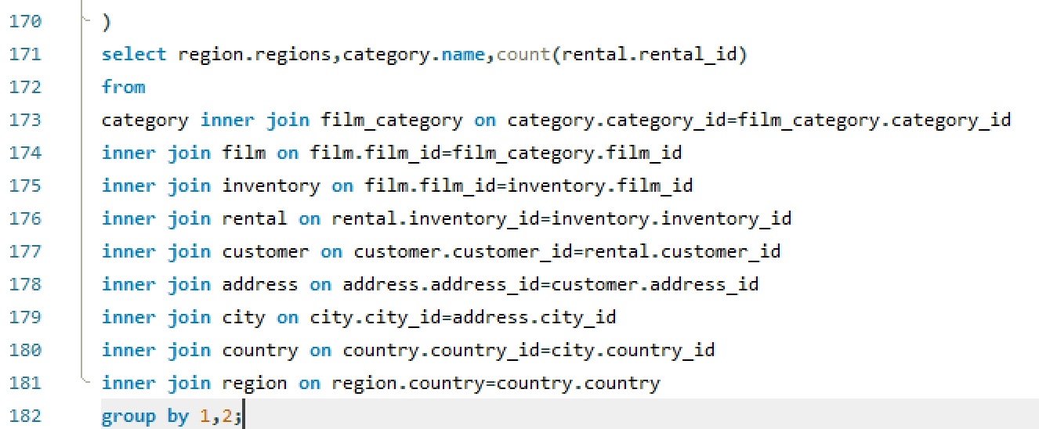

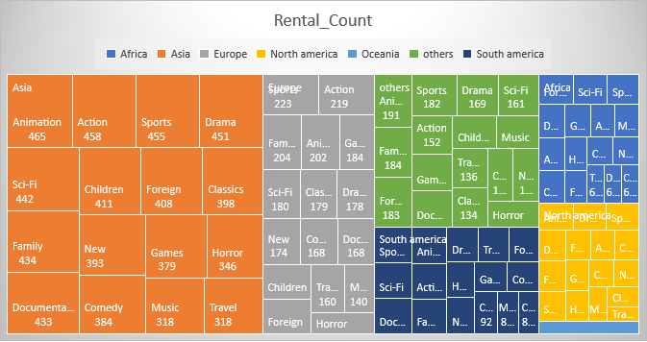

From the above tree chart, I can conclude that Asia, North America and other regions inclined towards animation movies most where Europe, South America tends to watch sports movies and in Africa peoples like to watch foreign movies.

1. How does the availability and knowledge of staff affect customer ratings?

Staff availability and knowledge directly impact customer ratings. Accessible, knowledgeable staff tend to lead to higher ratings, while unhelpful or uninformed staff can result in lower ratings.

NOTE: There is no relevant data available for customer rating. Also, after studying the data, I didn't get any insight of knowledge of staffs. So, I have gained insight about rating wise availability of films in each store which is one of the problem statements in my MECE breakdown of the given dataset.

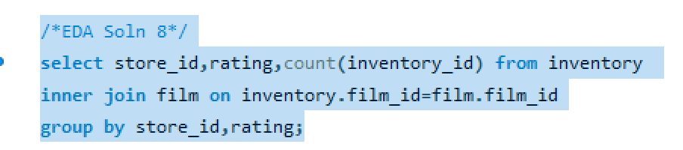

|  |  |  |
| --- | --- | --- |
| Store_Id | Rating | Film_count |
| 1 | PG | 444 |
| 2 | PG | 480 |
| 2 | G | 397 |
| 2 | NC-17 | 479 |
| 1 | G | 394 |
| 1 | PG-13 | 525 |
| 2 | PG-13 | 493 |
| 2 | R | 462 |
| 1 | NC-17 | 465 |
| 1 | R | 442 |

1. How does the proximity of stores to customers impact rental frequency?

Store proximity to customers directly affects rental frequency. Closer stores often lead to more frequent rentals due to increased convenience, while greater distances can reduce rental frequency.

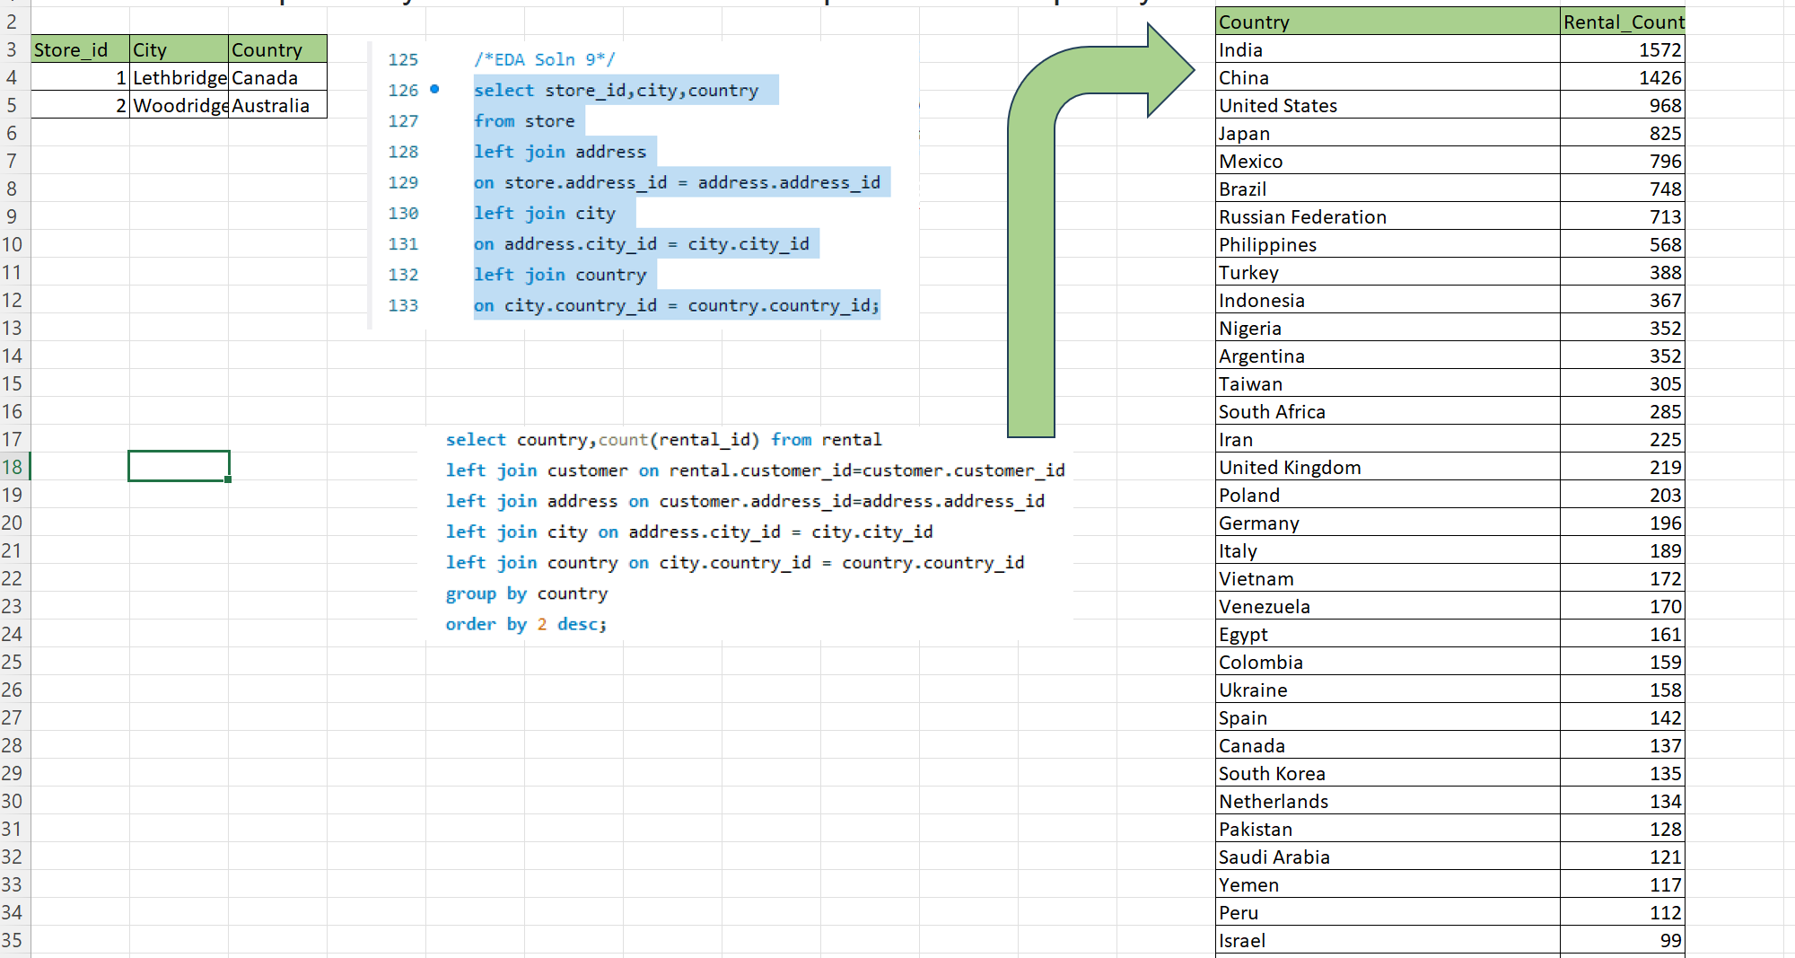

To solve this problem, we can take the location info from the address table, take latitude longitude of that location and derive the distance from the customers address to the store’s address to see how the proximity impacts the rental frequency. But in the given data set the location of the stores are in two countries only that is Canada and Australia. But the maximum times movies have been rented from the countries like India China United States Japan Mexico Brazil etc. From this observation we can see that there is no correlation between the distance from the store to customer address and rental frequency.

1. Do specific film categories attract different age groups of customers?

Specific film categories often attract different age groups of customers. For example, animated films may be popular among children and families, while action or thriller genres may appeal more to younger adults. Understanding the age group preferences for various film categories can help businesses target their audience more effectively and tailor their offerings to specific demographics.

In the given data set we didn’t have Information about customers age in any table. Hence, I have segregated age group by dividing the movies according to their rating like the R rated movies can only be rented by customers who are above 18, PG13 movies can only be rented by customers whose age are more than 13. likewise, I have divided all the customers according to the movies they have rented.

After this segregation, we farther divided the film categories according to the number of rentals by customers. I have added a slicer as it can be seen in the attachment below which have 4 age groups like above 13 years, above 18 years, above 7 years and all age.

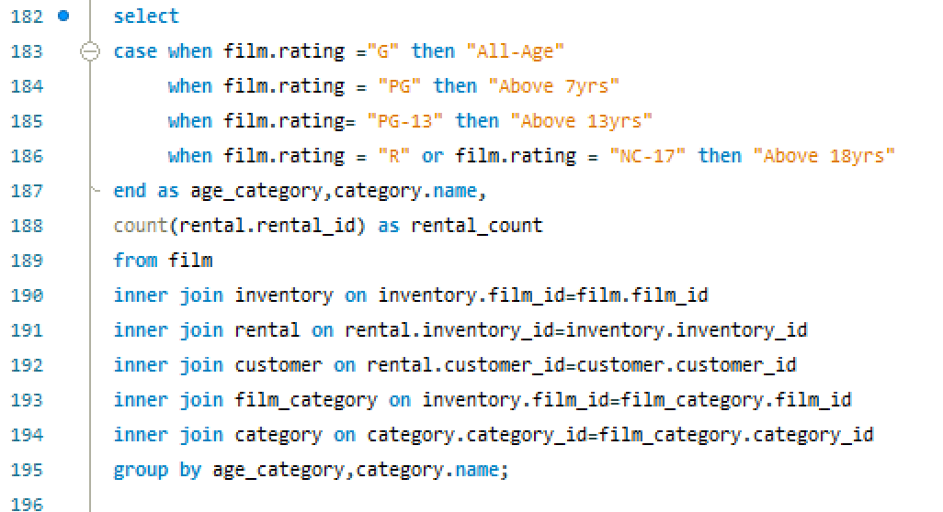

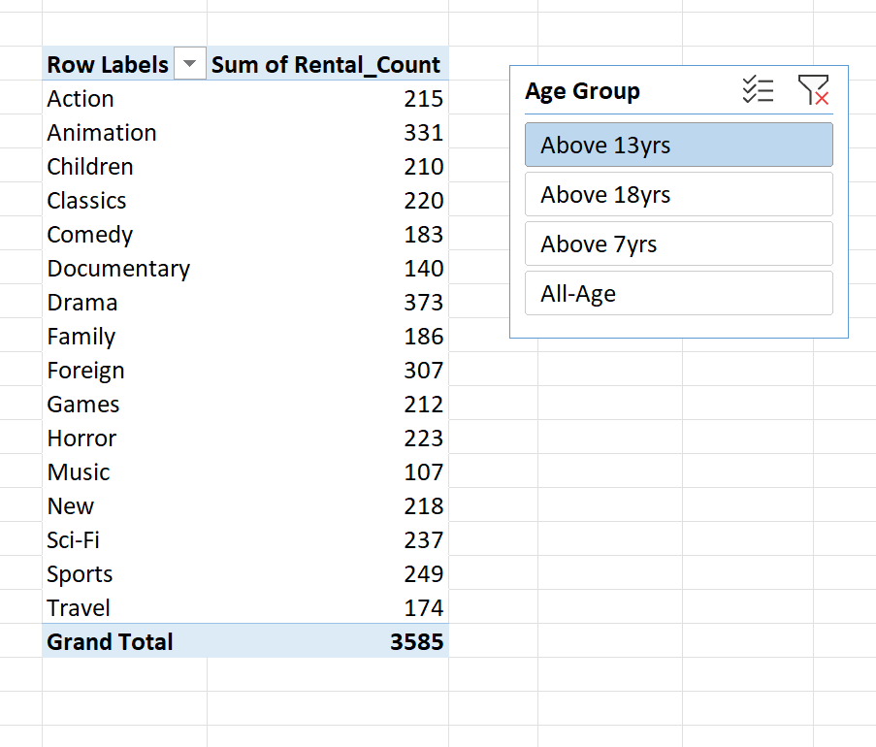

From the above chart we can clearly understand how certain categories of films are preferred more by customers above age 13years. Like Drama & Animation films are most popular among customer over 13 years.

1. What are the demographics and preferences of the highest-spending customers?

High-spending customers tend to have higher incomes, value quality, appreciate personalization, prioritize convenience, and may favor luxury, exclusivity, and brand loyalty. Demographics vary but often include middle-aged to older individuals in urban areas.

To find out high spending customers firstly I have written a SQL query to find out top 20 customers by sales revenue.

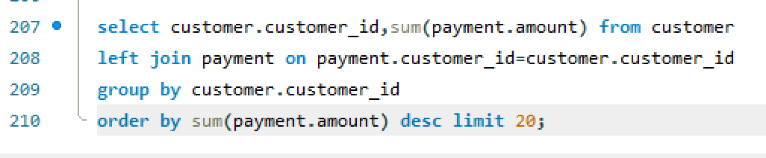

|  |  |
| --- | --- |
| Customer_Id | Payment |
| 526 | 221.55 |
| 148 | 216.54 |
| 144 | 195.58 |
| 178 | 194.61 |
| 137 | 194.61 |
| 459 | 186.62 |
| 469 | 177.6 |
| 468 | 175.61 |
| 236 | 175.58 |
| 181 | 174.66 |
| 176 | 173.63 |
| 259 | 170.67 |
| 50 | 169.65 |
| 522 | 167.67 |
| 410 | 167.62 |
| 403 | 166.65 |
| 295 | 162.62 |
| 209 | 161.68 |
| 373 | 161.65 |
| 470 | 160.68 |

After getting the top 20 Customers’ customer_id I have written another query to find out their behavior pattern like what category of films they are preferring and what rated films they are watching.

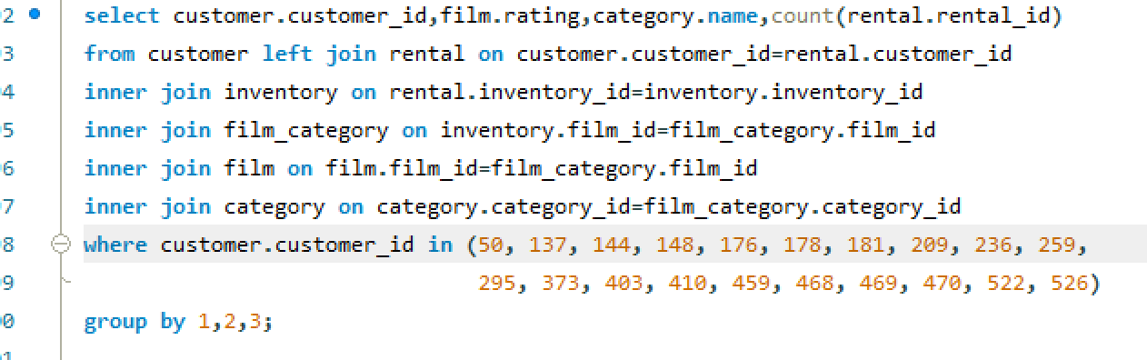

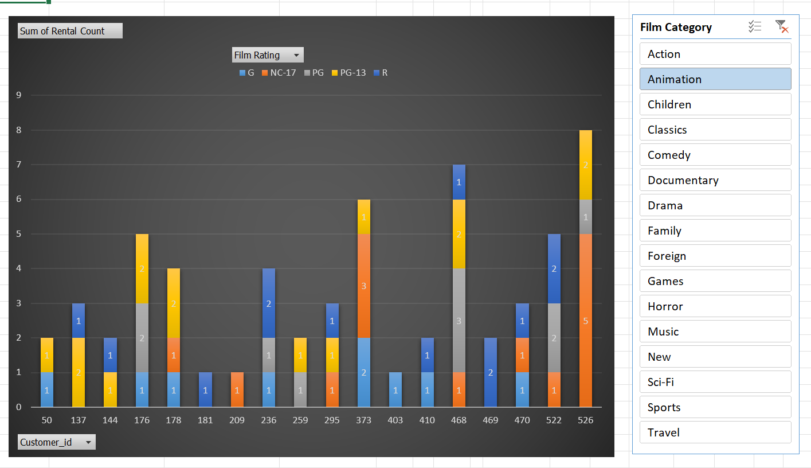

In the above stack column chart, I have taken customer ID in the X axis and number of movies rented in the Y axis. I have taken film_rating in legends and Film_category as a slicer to find out customers purchasing pattern.

This analysis will help to create a profile of highest-spending customers and tailor offerings to better meet needs and retain their loyalty.

1. How does the availability of inventory impact customer satisfaction and repeat business?

Inventory availability directly impacts customer satisfaction and repeat business. Adequate stock leads to happy customers who return, boost your reputation, and give you a competitive edge.

NOTE: To find out availability of inventory we need data related to stock maintenance, customer request and to get insight of customer satisfaction we need data related to customer rating, review or feedback. But we don’t have any of these data in the given dataset. Hence, we cannot provide a particular solution for the given problem statement.

However, I have identified how many times customers have returned the product early or on time and also the times when customers have returned the rented DVDs lately. By this we can get a bird view understanding of how many times repeated business got impacted and about customers’ behavioral pattern.

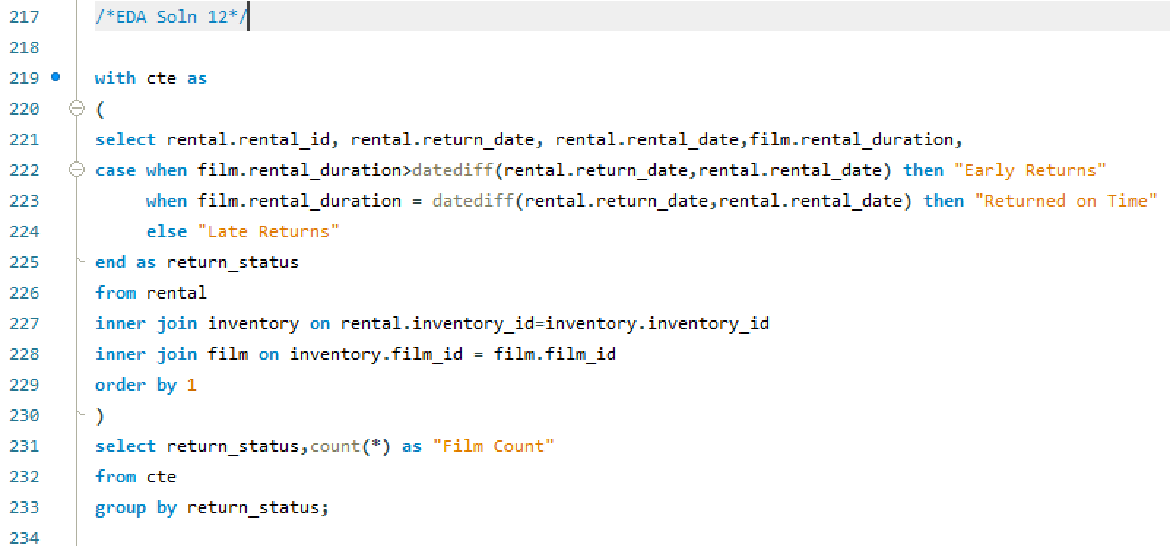

|  |  |
| --- | --- |
| Return_Status | Film Count |
| Early Returns | 6864 |
| Late Returns | 7452 |
| Returned on Time | 1728 |

From the above table it is clear that most of the DVDs rented have returned lately i.e. 46% . This is a clear indication that by optimizing the procurement process of rented DVDs we can increase the repeat business and overall sales can also be increased.

1. What are the busiest hours or days for each store location, and how does it impact staffing requirements?

Identifying peak hours and days for each store and adjusting staffing accordingly enhances efficiency and customer satisfaction. This strategic approach balances service quality with cost control and adapts to changing customer traffic patterns.

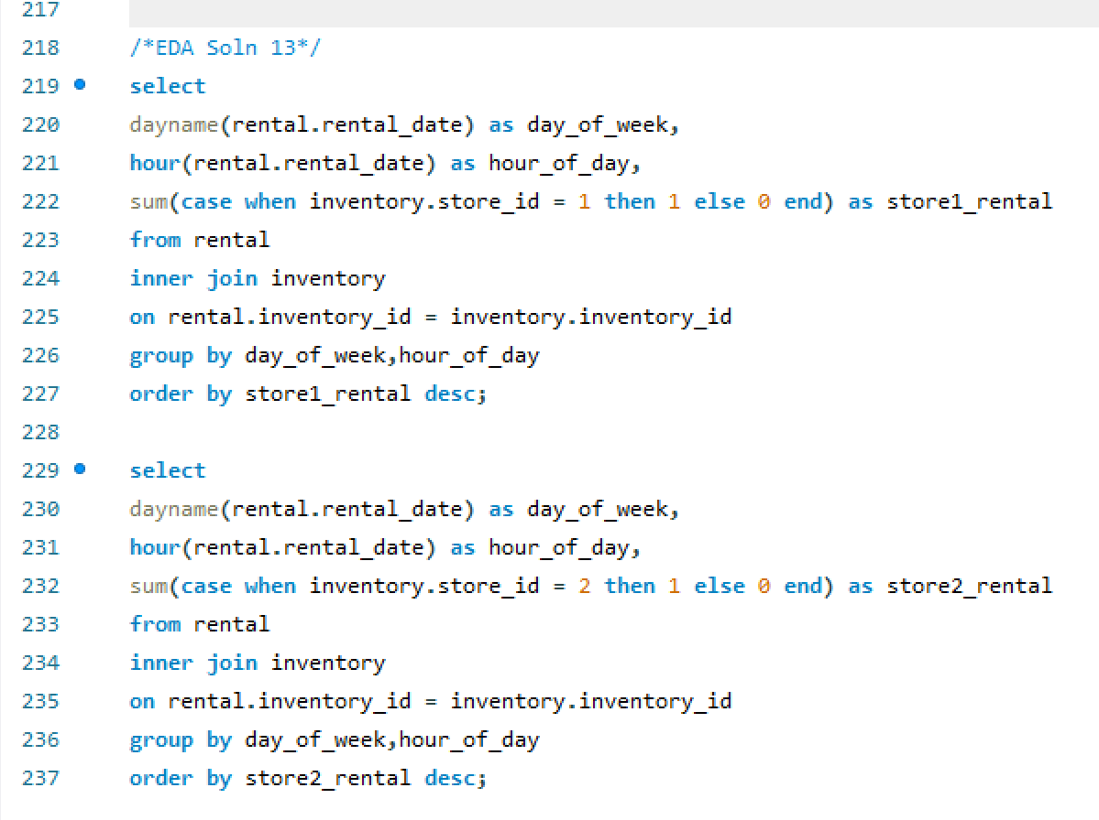

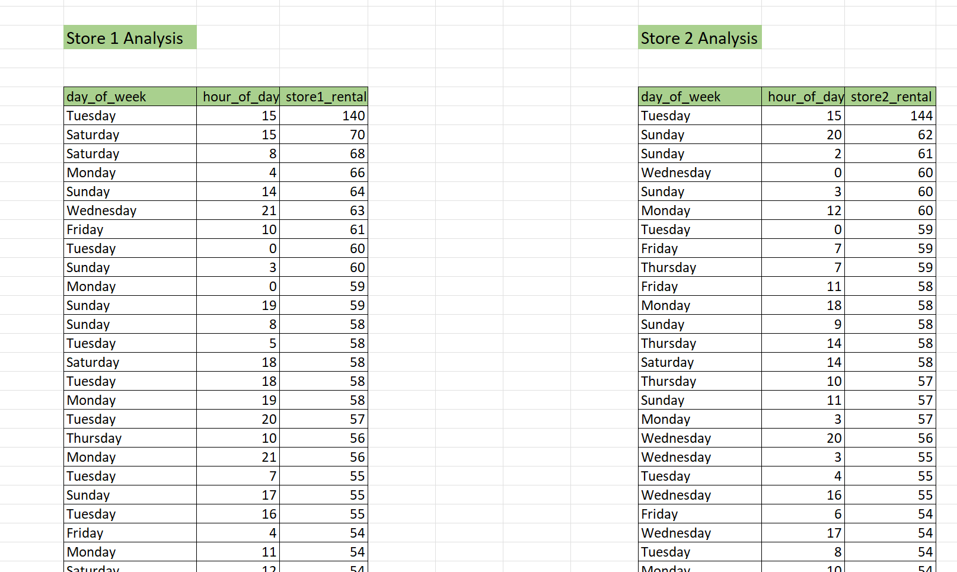

By analyzing Store table inventory table and rental table it is clear that Tuesdays 3:00 PM are the busiest hours of the whole week followed by Sundays input the stores. However, From the given dataset we can understand that there is only 1 staff in each store and there is no data provided for staff requirement or staff feedback or store feedback to gain insight about reequipments and pain points. Hence, second part of the given problem statement cannot be analyzed.

1. What are the cultural or demographic factors that influence customer preferences in different locations?

Cultural and demographic factors, including cultural values, language, age, income, lifestyle, religion, education, and social trends, significantly influence customer preferences in different locations. Businesses must consider these factors to tailor their offerings effectively.

To analyze the given problem statement, I have taken region wise customer count and their preferences of movies based on the movie rating.

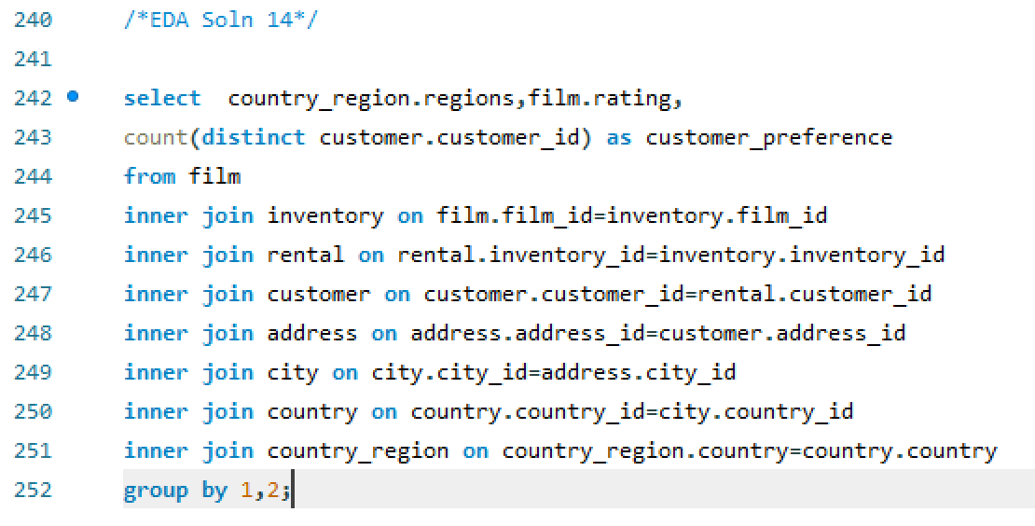

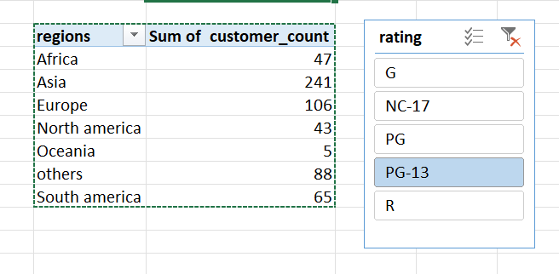

To analyze the given problem statement, I have taken region wise customer count and their preferences of movies based on the movie rating.

From the above column chart, it is clear that PG13 movies are most watched by customers of Asia.

1. How does the availability of films in different languages impact customer satisfaction and rental frequency?

Availability of films in different languages boosts customer satisfaction and rental frequency by catering to diverse preferences and attracting a broader audience.

NOTE: In the given dataset all the films are in English language and there is no rating or feedback table for customers. Hence, we cannot be able to find solution for the given problem statement.

So, I have gained insight about the co-relation between the length of Films and number of times rented.

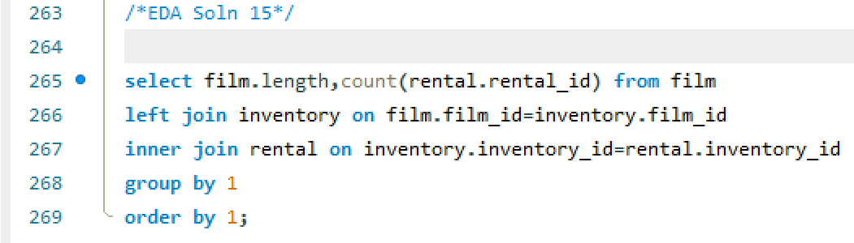

From the above scatterplot you can see that as the movie’s length increases so does the number of times the movie got rented. However, there are some exceptions where short films got rented many times. But overall, the rental count is increasing with movie duration. This analysis can be helpful to improve business strategies like -

Pricing Strategy: One possible insight is that longer films may be priced differently or more favorably than shorter films. Businesses could consider adjusting rental prices based on the length of the film.

Content Acquisition: Knowing that longer films are more popular for rentals, businesses might consider acquiring or licensing more long-form content to meet customer demand. They can use this information to make informed decisions about expanding their movie library.

Customer Preferences: This trend could also reflect customer preferences. Businesses can use this insight to tailor their recommendations and marketing strategies to promote longer films to customers who enjoy them, potentially leading to increased revenue.

Inventory Management: Understanding the demand for longer films can help with inventory management. Businesses can stock more copies of popular longer films to minimize stockouts and maximize rental revenue.

Marketing Campaigns: Businesses can create targeted marketing campaigns to promote longer films during specific seasons or events when customers are more likely to rent and watch them.

POWER BI PROBLEM STATEMENTS

1. How does the revenue vary by month?

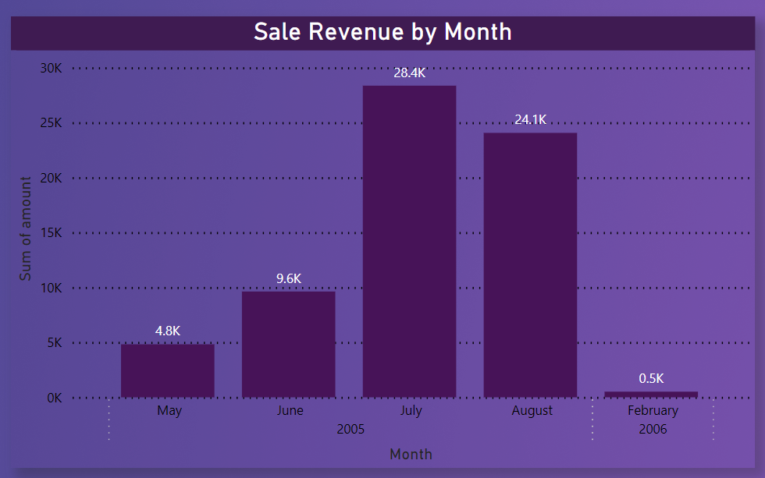

After plotting amount in the Y axis and rental date on the X axis I have observed that sales revenue is increasing month by month starting from May till July and there is a minimal drop in August. After that there is no data on sales from September to January. In 2006 February, there is a little bit number of sales(.5K) been observed from the from analyzed chart. Hence, we can Only conclude that in the month of July the sales was the highest but as data were missing for the last five months of 2005 we can’t predict any particular trend.

1. What is the distribution of sales by payment method?

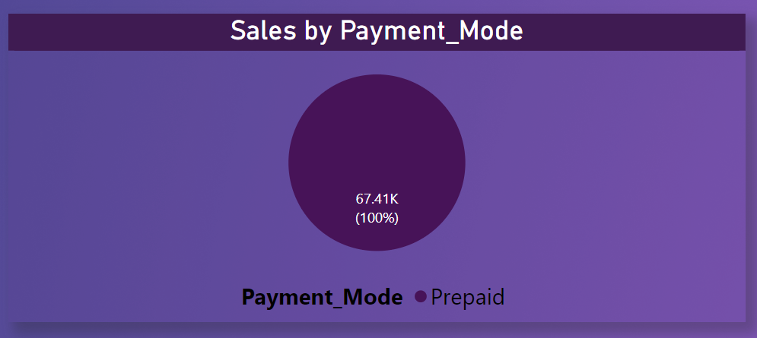

There is no data available regarding the payment method of the customers like gas payment or online payment. Hence, I have checked the available data and compared the rental date from the rental table and payment date from the payment table and segregated the customers based on that. If the rental date and the payment did is same then it’s a prepaid else postpaid and by observing all over the data set 100 percent the payment has been done in prepaid mode only.

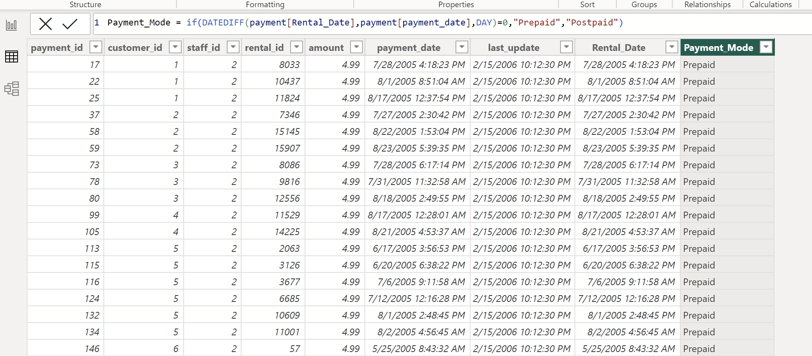



In power BII have created a calculated column highlighted above to find out whether the payment has been made upfront or not.

1. Which customer segments generate the highest sales?

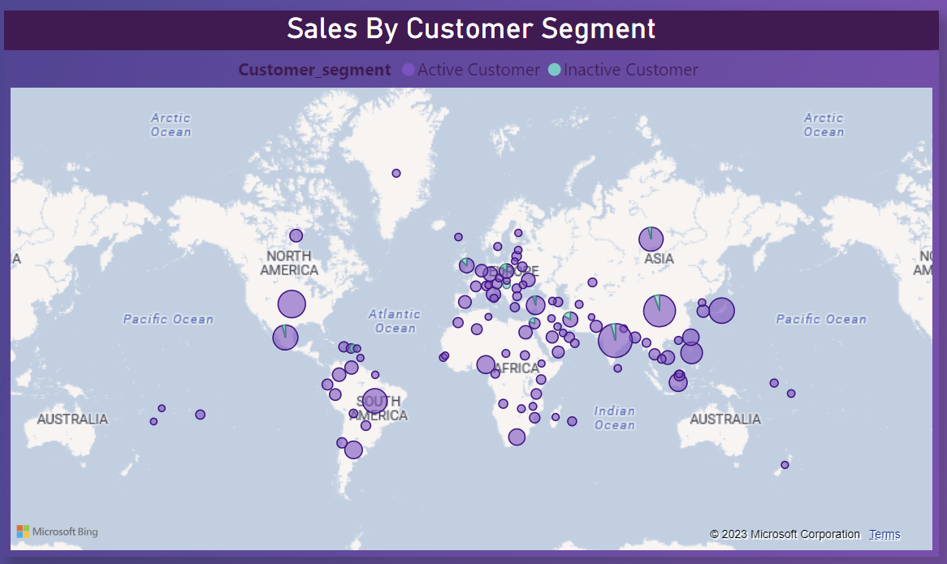

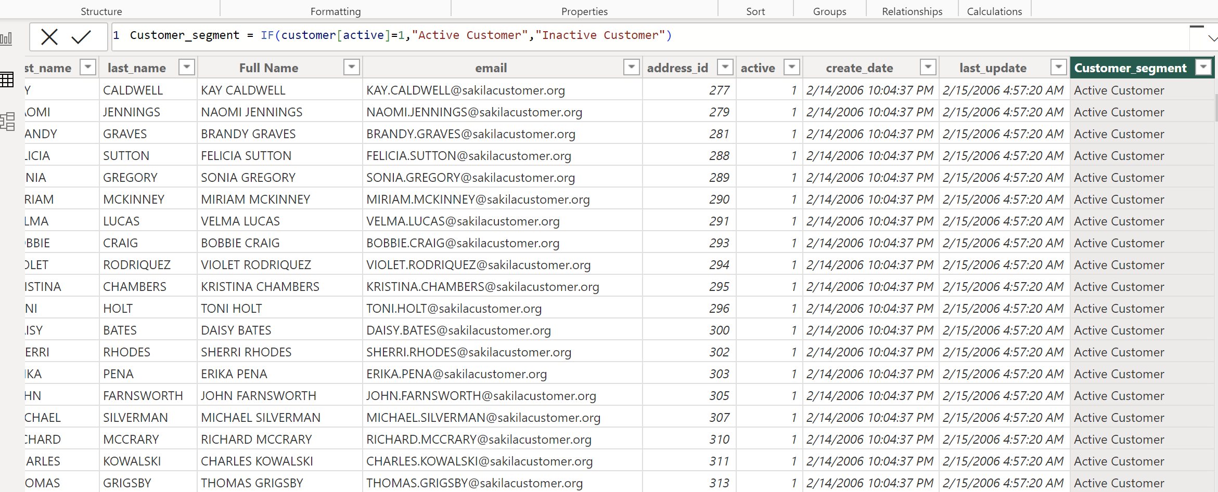



In the above problem statement, we have been asked the sales generated by different customer segment hence I have segmented customer based on their current status whether the customer is still active or not. In the above screen shot it is shown that I have created and calculated column of the same.

Following that I have Built a report based on customer’s location and taken how sales has been generated by different customer segments.

1. What is the distribution of films by rental duration?

The distribution of films by rental duration refers to how films are categorized based on the time frame for which they can be rented. This typically includes categories such as short-term rentals (e.g., 1-day rentals), medium-term rentals (e.g., 3-day rentals), and long-term rentals (e.g., 7-day rentals).

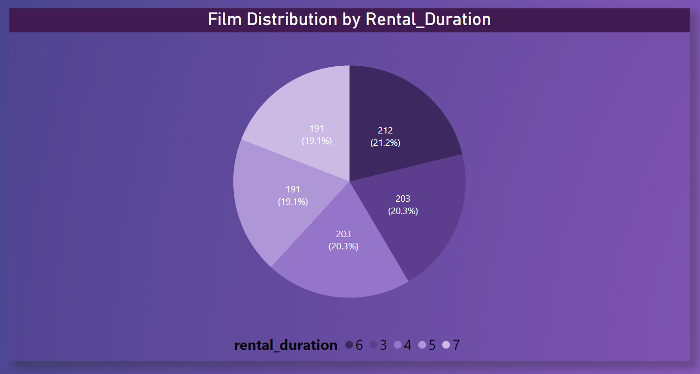

From the above pie chart, I can surely tell that The distribution of films according to the rental duration is almost 20% for all the categories.

1. How does the inventory vary by film rating?

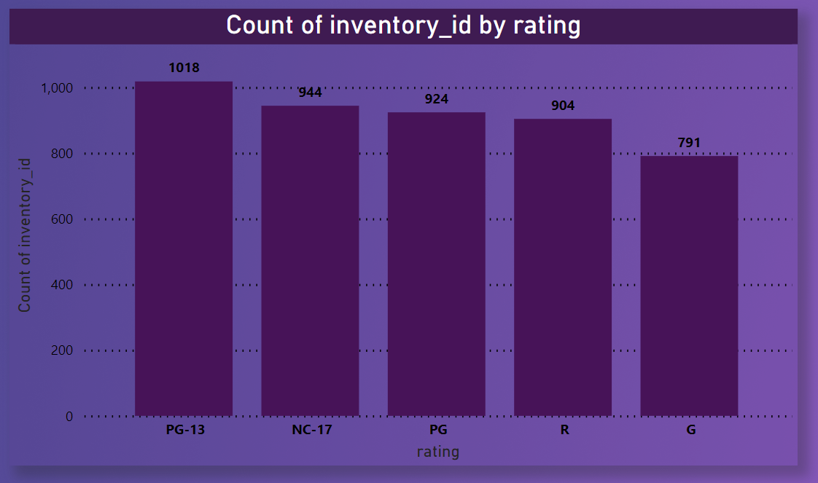

To solve the given problem statement, I have taken film rating on X axis and inventory count on the Y axis and plotted column chart. The insight I get is that collection of PG13 movies in the stores is highest among all others.

1. What is the breakdown of film categories in the inventory?

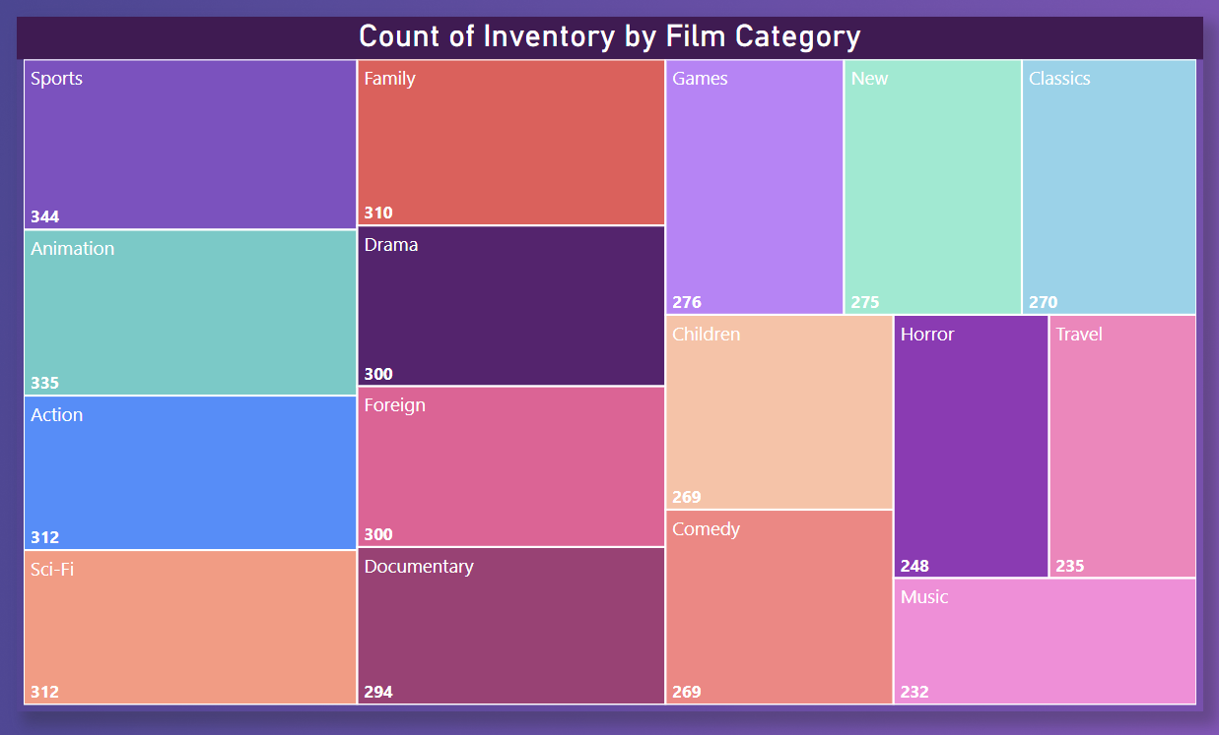

By breaking down the inventory based on the available film category I have observed that maximum number of films are from sports category, followed by animation, action, sci-fi, family, drama etc.

1. What is the distribution of staff by employment duration?

NOTE: There is no relevant data available in the given dataset to derive insight for the above problem statement. To find out staff performance we need data like customer feedback based on staffs, sales by staff, payment collection by staff, employment duration, working hours, etc.

So, I have delved one of my MECE breakdowns i.e., the distribution of inventory for each store and observed that both stores have almost similar number of film collections.

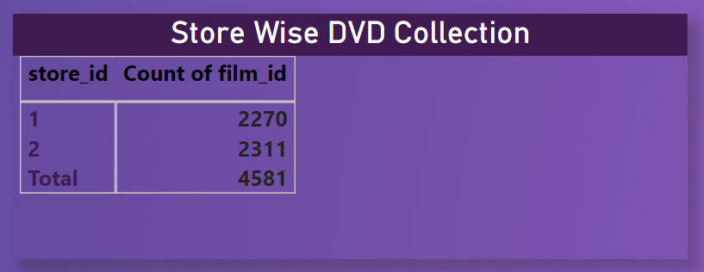

1. How does the store performance vary by location?

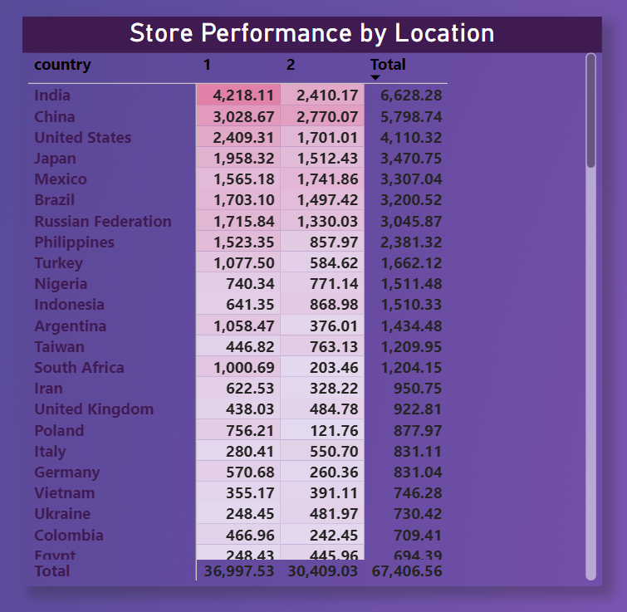

For the above problem statement, I have broken down the store’s rental revenue by country. The insights I got from this analysis is that store 1 performs better than the store 2 by roughly 18%. Also in some countries like India, Germany, South Africa, Colombia total revenue generated by store 1 is much higher than revenue generated by store 2.

1. What is the average rental duration by staff member?

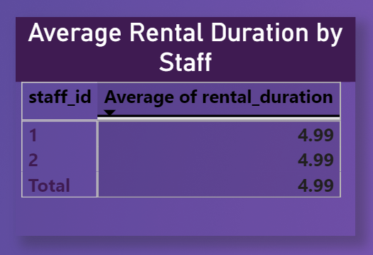

By observing the rental table and film table the average rental duration by staff member came out to be 4.99 which indicates that the average time one movie is rented is for 5 days.

1. What is the distribution of customers across different cities?

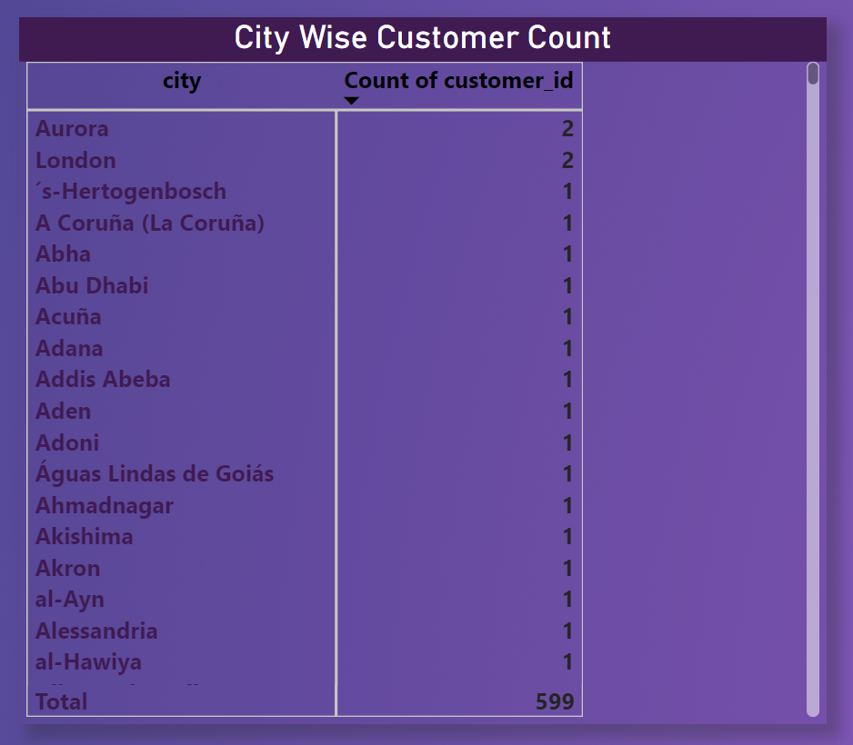

By observing the findings of the given problem statement, I have understood that only two cities Aurora and London has two customers else every other city has only 1 customer. From this data we can conclude that though our customer base is whole world but the number of customers from each city is very less.

1. How does the rental revenue vary by country?

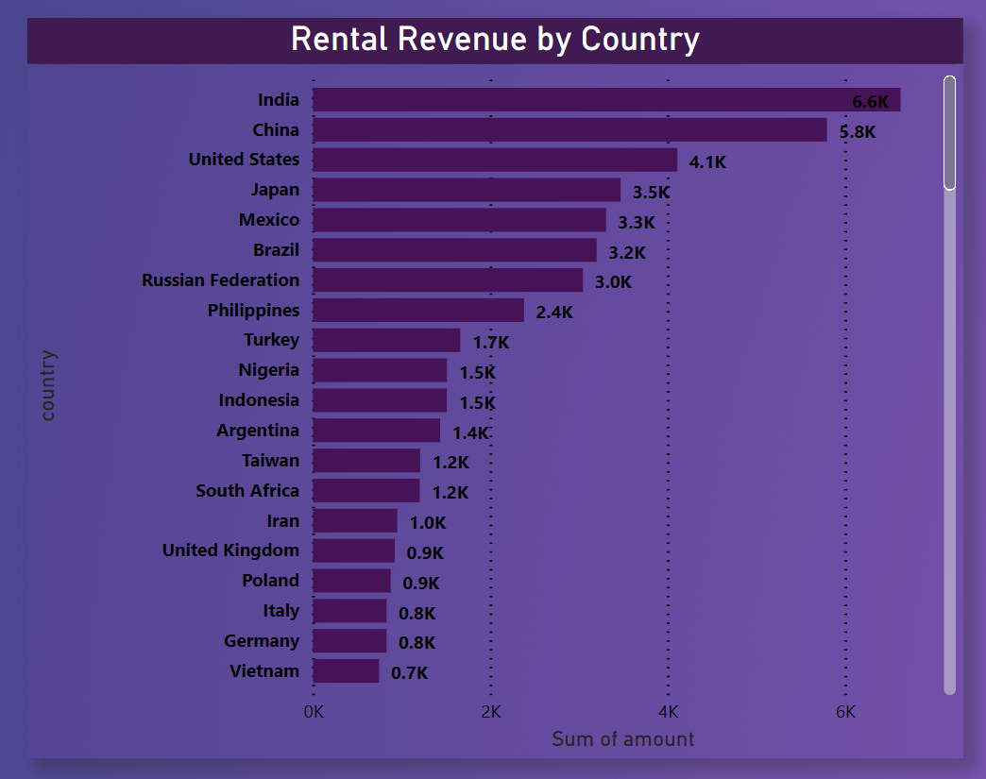

The insight I got from this report is that India is the highest revenue generating country followed by China, United States, Japan so and so.

1. Which locations have the highest and lowest customer ratings?

NOTE: There is no relevant data available in the given dataset to derive insight about customer rating. Hence, the given problem statement cannot be solved.

So, I have delved one of my MECE breakdowns i.e., customers monthly rental pattern.

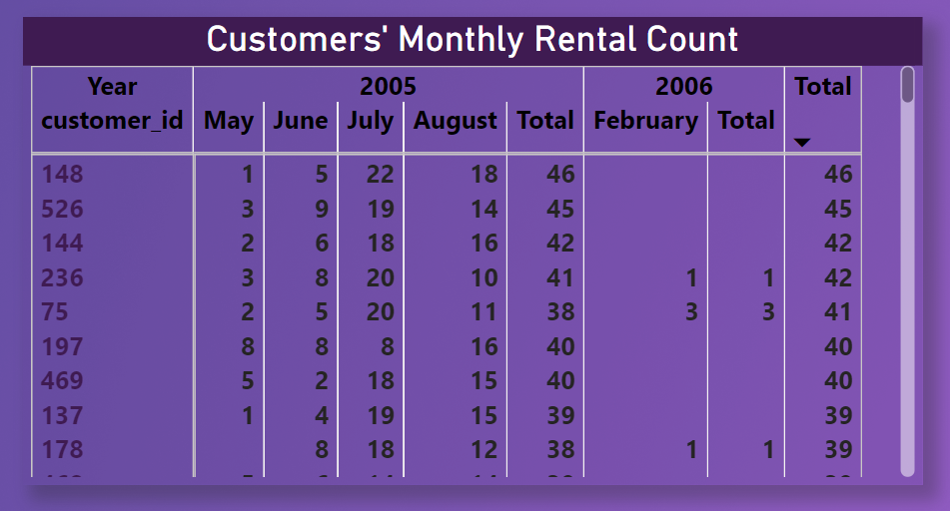

From the above findings I observed that customer with id #148 has the highest rental count over the time though he or she haven't rented any films in 2006. The matrix represents all the customer ids in descending order of their total movie rented over the years.

From the data I observed that some of the high value customers doesn’t make any transaction in 2006.

With effective marketing, personalized discounts, improving inventory & listening to customer feedback we can regain our customer loyalty and also it will lead to overall sales.

1. What is the distribution of films by language?

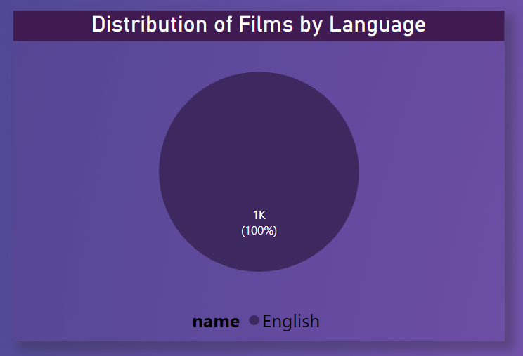

Though they there are six languages in the given data set table languages but all the films in the film table are in one language that is English. Hence as the asking of the given problem statement distribution of films by language, the report generated is that 100% of the movies are in English language.

The entire film collection in the dataset is exclusively in the English language, representing 100% of the movies. This suggests a lack of language diversity in the available films, which may limit the company's ability to cater to a broader international audience with different language preferences. To attract a more diverse customer base and expand market reach, it may be beneficial to consider acquiring or offering films in a variety of languages.

1. Which film categories have the highest rental rates?

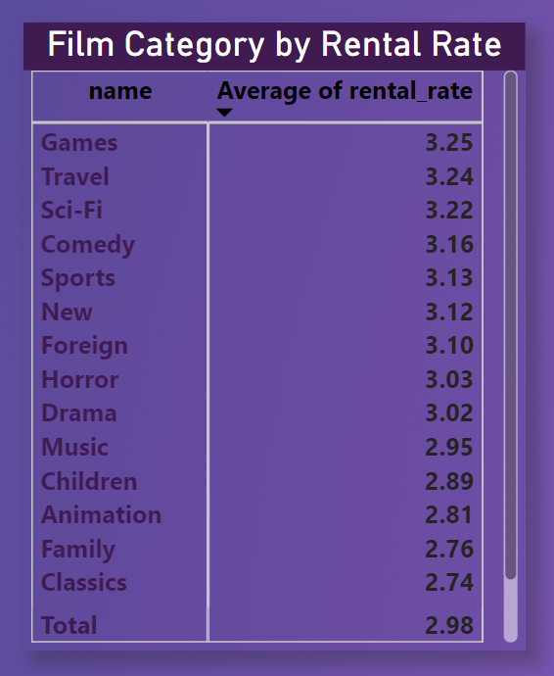

After delving the problem statement into Power BI report I generated, has been depicted in the above screenshot. It is clear from the report that the games category films have the highest average rental rate followed by travel and sci-fi movies.

1. How does the average rental duration vary by film category?

The average rental duration can vary by film category. For example, films in different genres or categories may have varying appeal and engagement levels, leading to differences in how long customers typically rent them. Analyzing rental data can help us identify these variations and tailor the inventory or marketing strategies accordingly.

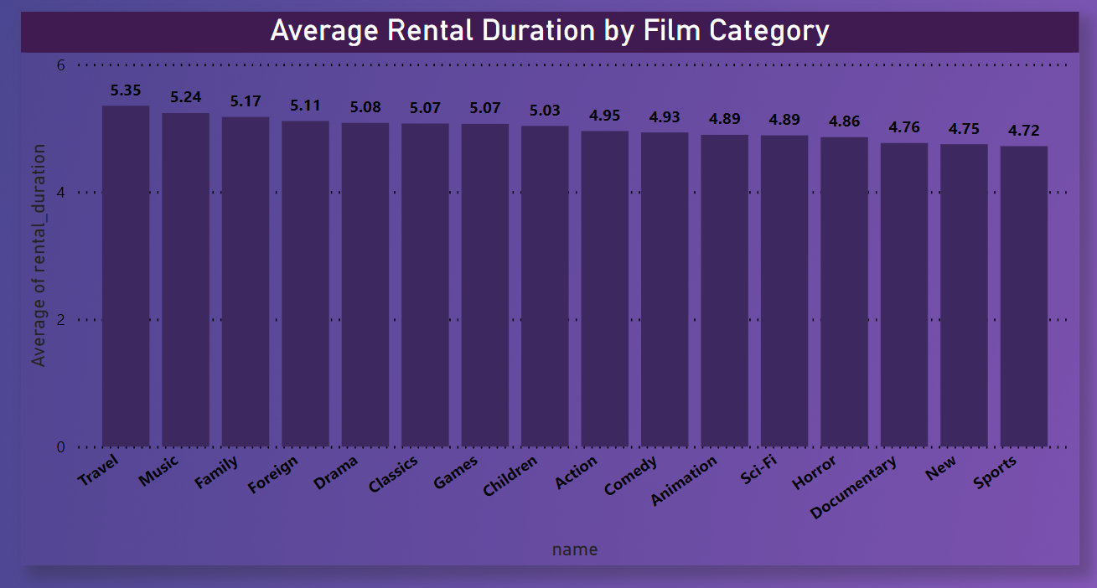

The Power BI report indicates that film category significantly impacts the average rental duration. Categories like "Travel," "Music," and "Family" tend to have longer rental durations, suggesting that customers in these categories may prefer to keep the films for extended periods, possibly for repeated viewing or enjoyment. On the other hand, films in the "News" and "Sports" genres have shorter rental durations, reflecting the nature of these genres as more time-sensitive or less likely to be rewatched. This information can guide inventory management, pricing strategies, and customer engagement efforts. It highlights the need to cater to the specific preferences and behaviors of customers within each film category to enhance the overall customer experience and optimize rental revenue.

POWER BI DASHBOARD

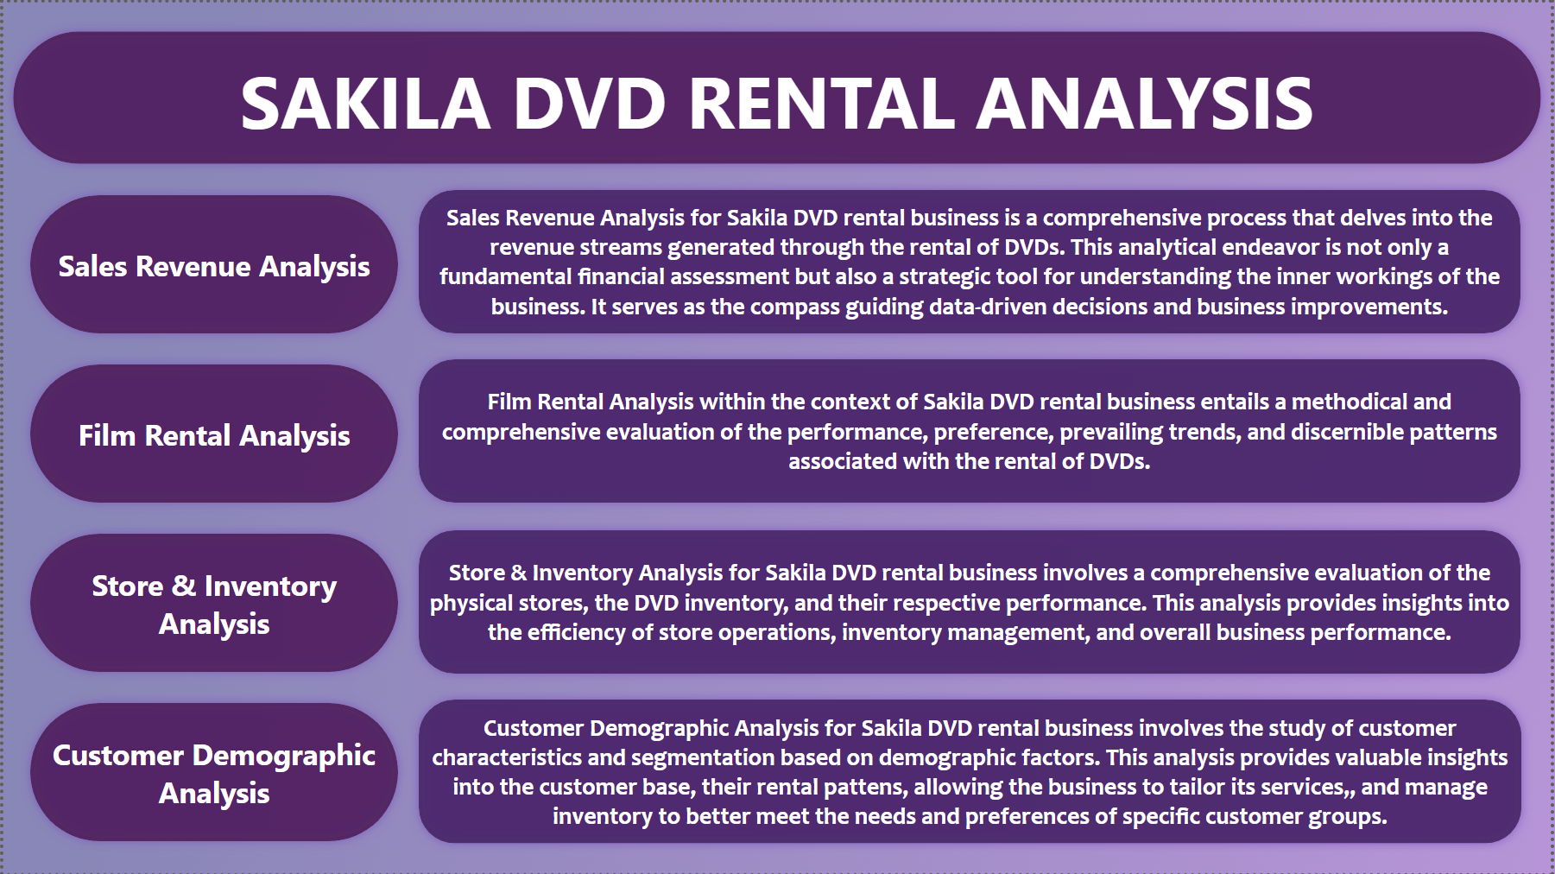

This is the overview page of Sakila DVD Rental Store Analysis Dashboard where I have segregated the given 15 problem statement into four major categories and added some extra KPIs By myself to better understand the data and derive meaningful insights for enhancing data driven decision making.

The four major analyses are Sales Revenue analysis, Film Rental Analysis, Store & Inventory Analysis and Customer Demographic Analysis.

Sales Revenue Analysis for Sakila DVD rental business is a comprehensive process that delves into the revenue streams generated through the rental of DVDs. This analytical endeavor is not only a fundamental financial assessment but also a strategic tool for understanding the inner workings of the business. It serves as the compass guiding data-driven decisions and business improvements.

Film Rental Analysis within the context of Sakila DVD rental business entails a methodical and comprehensive evaluation of the performance, preference, prevailing trends, and discernible patterns associated with the rental of DVDs.

Store & Inventory Analysis for Sakila DVD rental business involves a comprehensive evaluation of the physical stores, the DVD inventory, and their respective performance. This analysis provides insights into the efficiency of store operations, inventory management, and overall business performance.

Customer Demographic Analysis for Sakila DVD rental business involves the study of customer characteristics and segmentation based on demographic factors. This analysis provides valuable insights into the customer base, their rental pattens, allowing the business to tailor its services, and manage inventory to better meet the needs and preferences of specific customer groups.

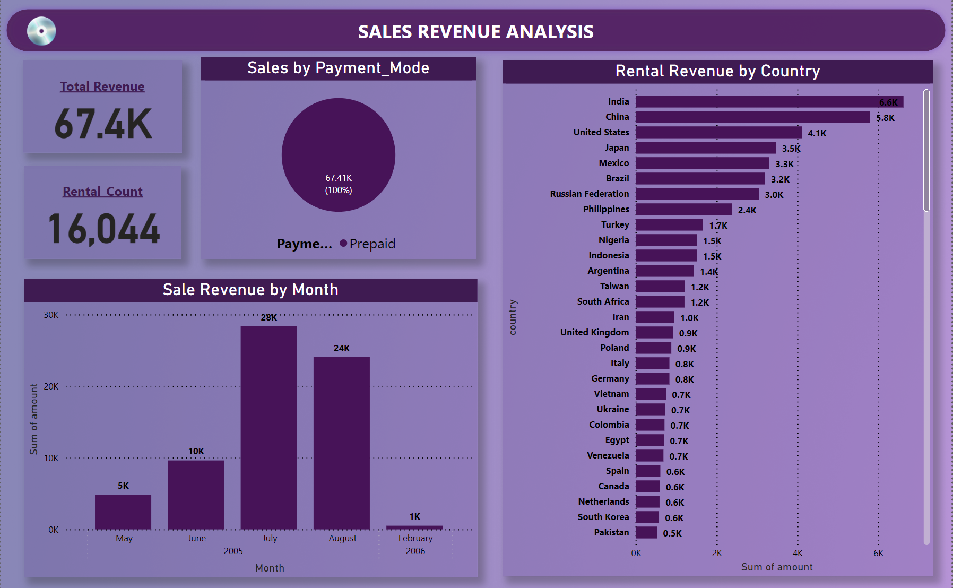

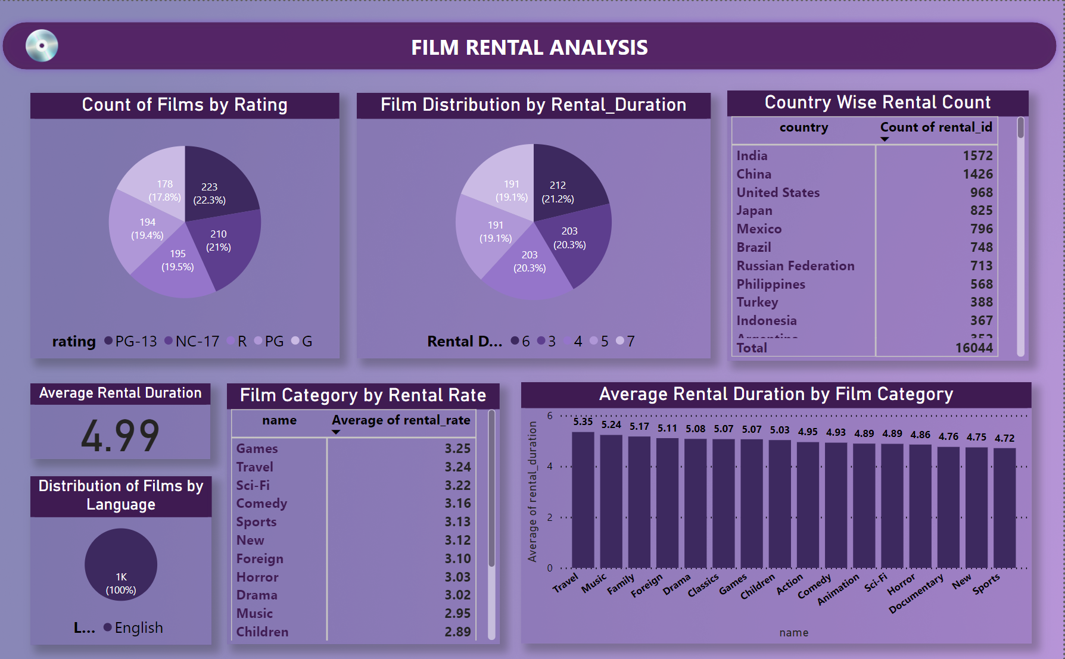

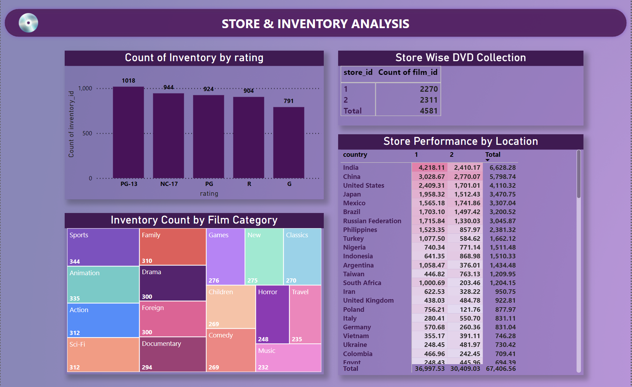

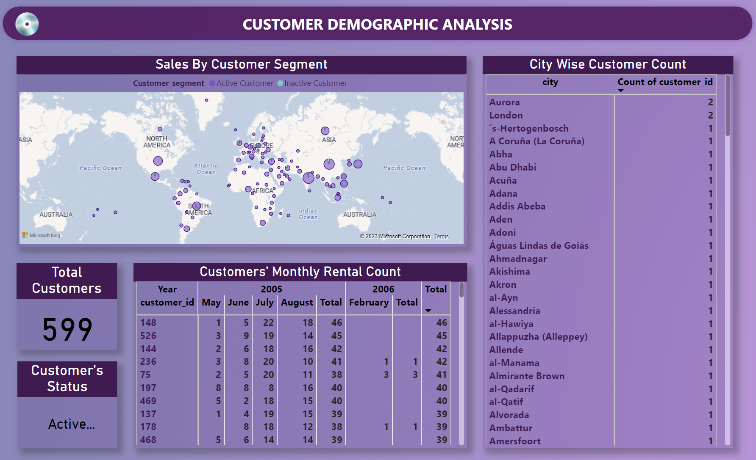

CONCLUSION

This Sakila DVD Rental Analysis project aims to provide a holistic view of our DVD rental business, enabling us to make data-driven decisions and improvements in sales, store operations, customer engagement, and movie rentals. By focusing on these key areas, we can enhance our performance, better serve our customers, and remain competitive in the DVD rental industry.

Sales Revenue Analysis: Our in-depth analysis of sales revenue data, facilitated by the integrated use of Excel, SQL, and Power BI, has provided valuable insights into the financial performance of the Sakila DVD rental store. By examining revenue trends over time and identifying peak revenue periods, we've established a foundation for more strategic decision-making. Power BI visualizations have allowed us to present this data in a clear and actionable manner, helping stakeholders quickly understand the business's financial health. Overall, this comprehensive analysis has equipped us with the tools needed to drive revenue growth and financial sustainability.

Film Rental Analysis: Our analysis of film rentals, accomplished through a synergy of Excel, SQL, and Power BI, has unveiled crucial insights into film popularity, customer behavior, and inventory management. By leveraging SQL queries, we've dissected rental data to identify top-performing films, actors, and genres. This information has been harnessed to optimize inventory and marketing strategies. Power BI visualizations have allowed us to showcase these insights effectively and guide film procurement decisions.

Customer Demographic Analysis: By employing SQL to segment customers based on various demographic attributes, we have developed a deeper understanding of our clientele, enabling personalized marketing and rental promotions. Excel has supported the creation of customer personas and data-driven customer relationship strategies. Power BI's interactive dashboards have given stakeholders a dynamic view of customer demographics, making it easier to design location-specific marketing and pricing strategies. This analysis has highlighted the importance of tailoring our services to the unique needs and preferences of various customer groups, ultimately enhancing customer engagement and loyalty.

Store & Inventory Management Analysis: Our analysis of store and inventory management, carried out using Excel, SQL, and Power BI, has been instrumental in improving operational efficiency and ensuring a satisfying customer experience. SQL queries have provided insights into inventory turnover, stockouts, pinpointing areas for improvement. Power BI's visualizations have enabled us to monitor these metrics in real-time, ensuring that inventory levels remain optimized and consistent. This analysis underscores the significance of streamlined operations and customer-centric inventory management in maintaining a successful rental business, all of which are made more actionable through the integration of these powerful data tools.

In summary, the combined use of Excel, SQL, and Power BI has empowered us to extract actionable insights from the Sakila DVD rental database in the domains of sales revenue, film rentals, customer demographics, and store/inventory management. These insights are pivotal in making data-driven decisions that enhance revenue, customer satisfaction, and the overall success of our rental business.